OOAD LAB EXPERIMENTS **DAY-3**

**19.AIM:-**

To develop a system using UML for Home Services System.

UML DESIGNS:-

1.USE CASE:

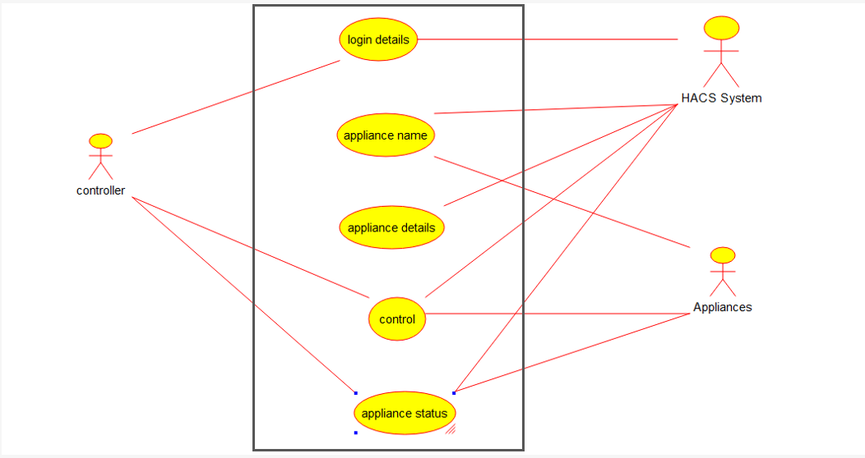

2.CLASS DIAGRAM:

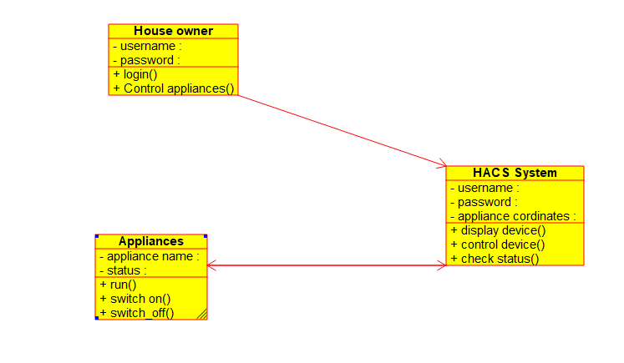

3.SEQUENCE DIAGRAM:

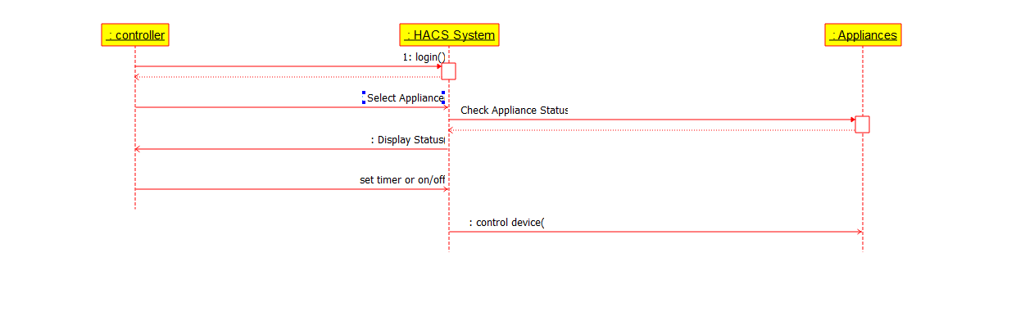

**20.AIM:-**

To develop a system using UML for Library Management System.

UML DESIGNS:-

1.PACKAGE DIAGRAM:

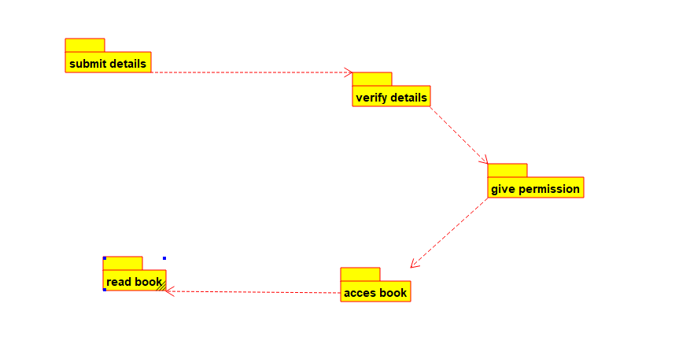

2.COMPONENT:

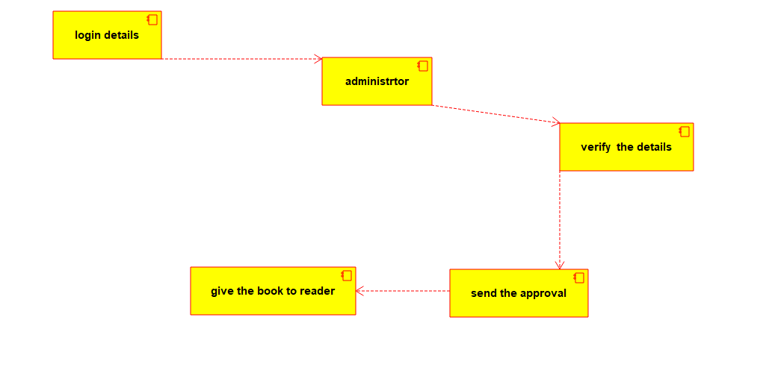

3.ACTIVITY DIAGRAM:

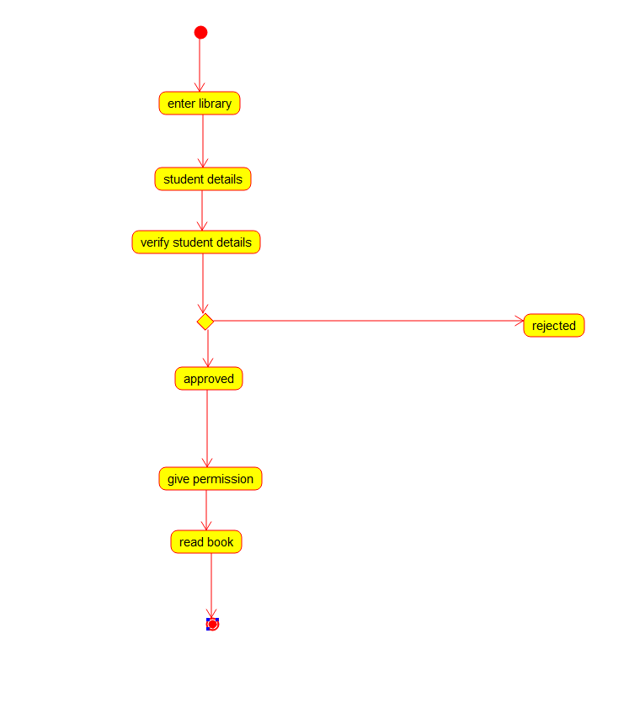

**21.AIM:-**

To develop a system using UML for Hospital Management System.

UML DESIGNS:-

1.COLLABORATION:

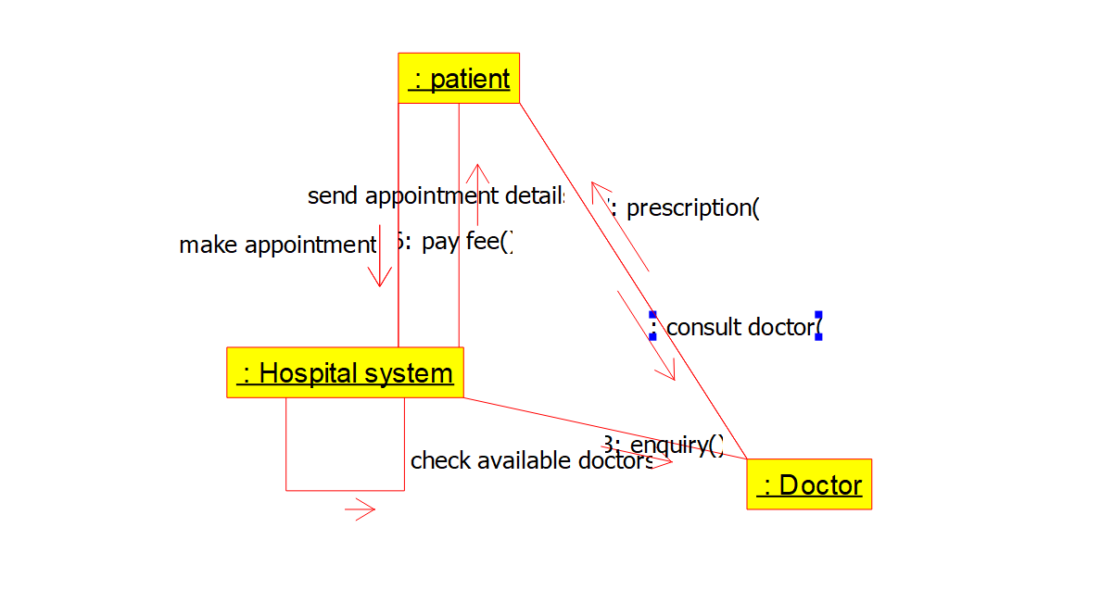

2.DEPLOYMENT DIAGRAM:

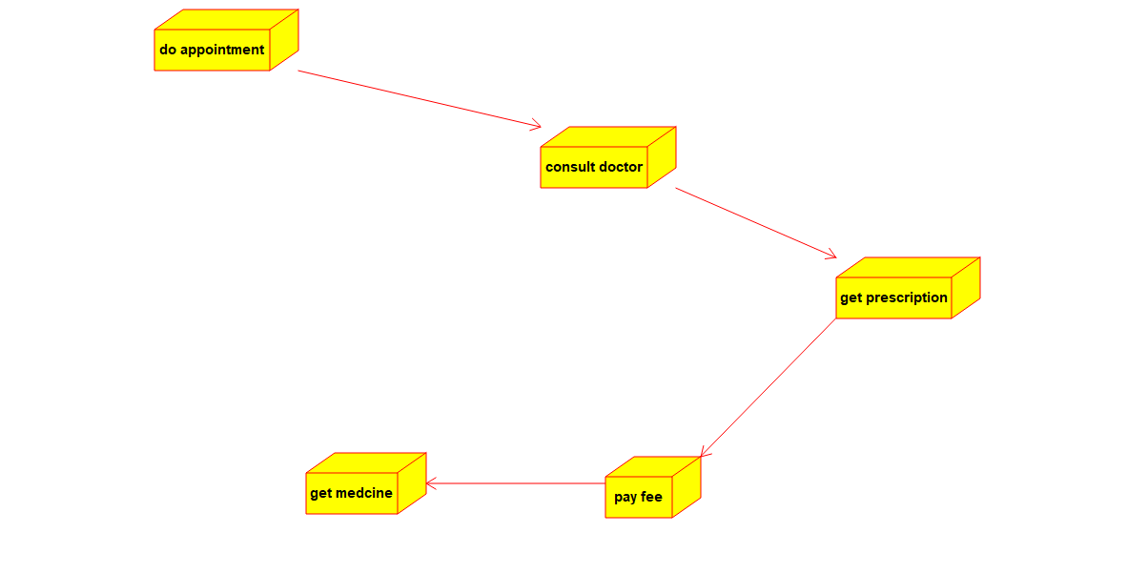

3.STATECHART DIAGRAM:

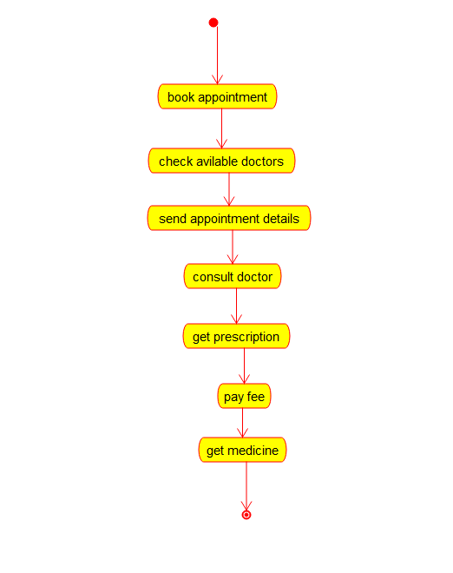

**22.AIM:-**

To develop a system using UML for Online Insurance Processing System.

UML DESIGNS:-

1.CLASS DIAGRAM:

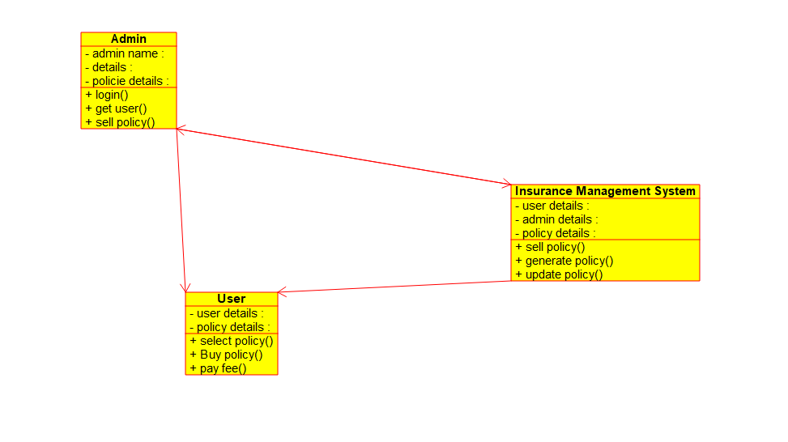

2.DEPLOYMENT:

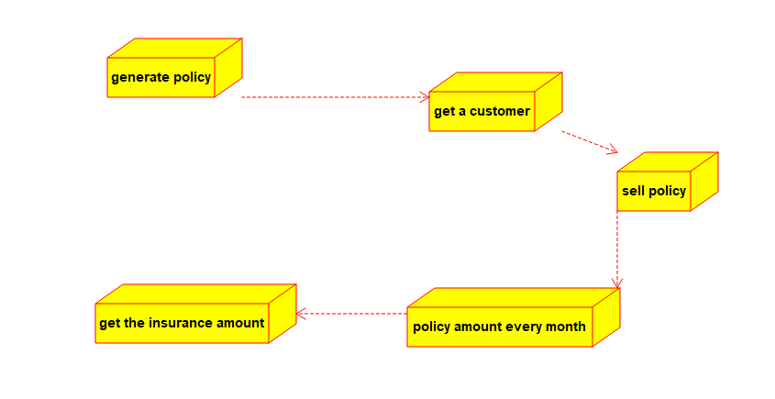

3.ACTIVITY DIAGRAM:

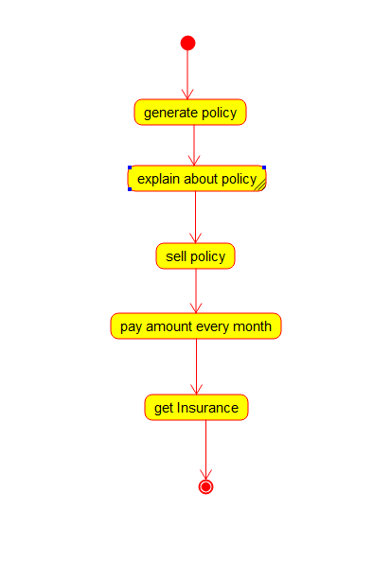

**23.AIM:-**

To develop a system using UML for Online Shopping System.

UML DESIGNS:-

1.COMPONENT:

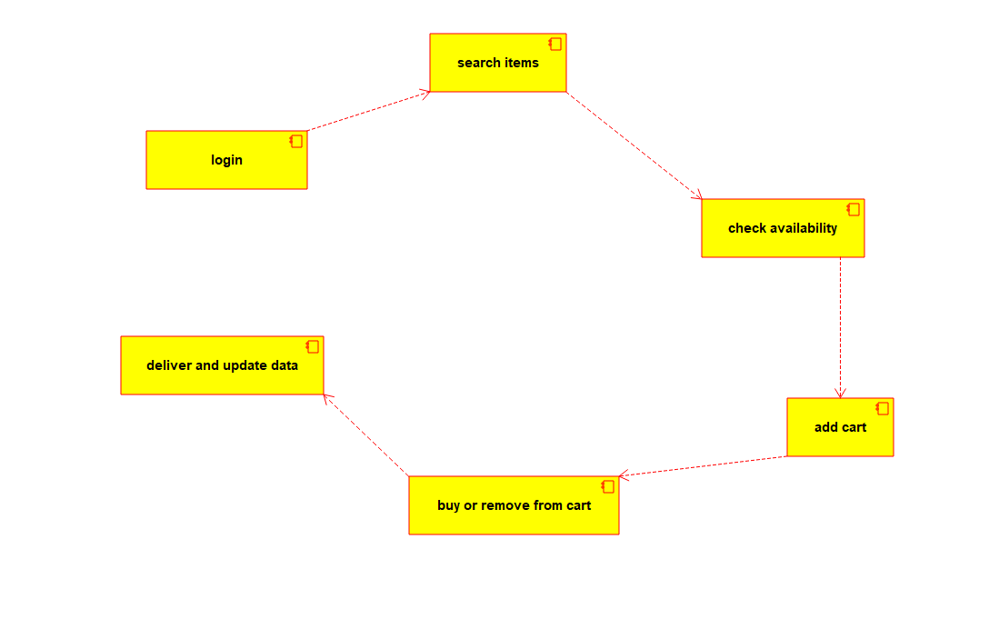

2.USECASE DIAGRAM:

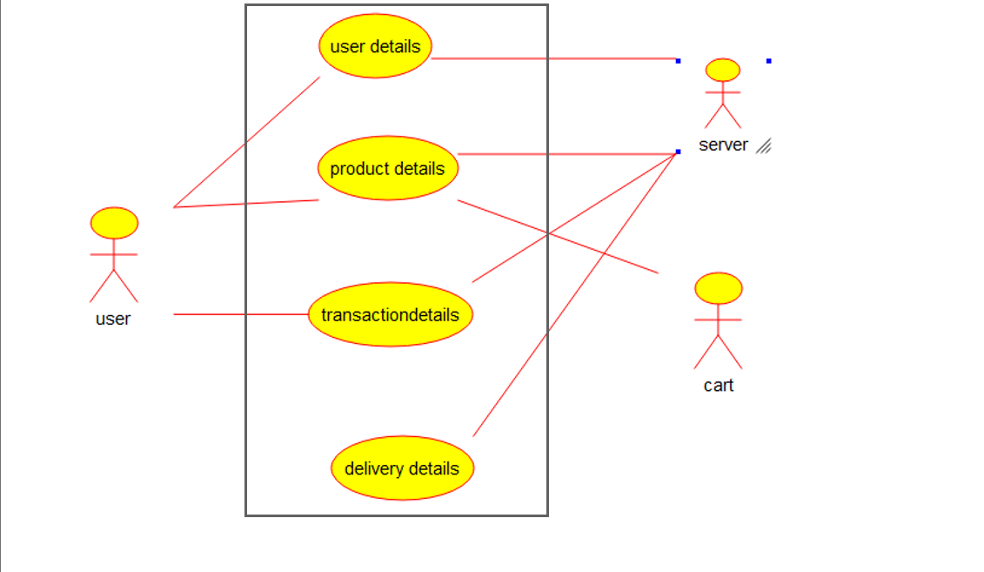

3.PACKAGE DIAGRAM:

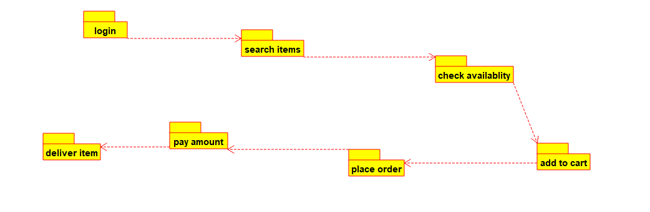

**24.AIM:-**

To develop a system using UML for Online Stock Market System.

UML DESIGNS:-

1.ACTIVITY DIAGRAM:

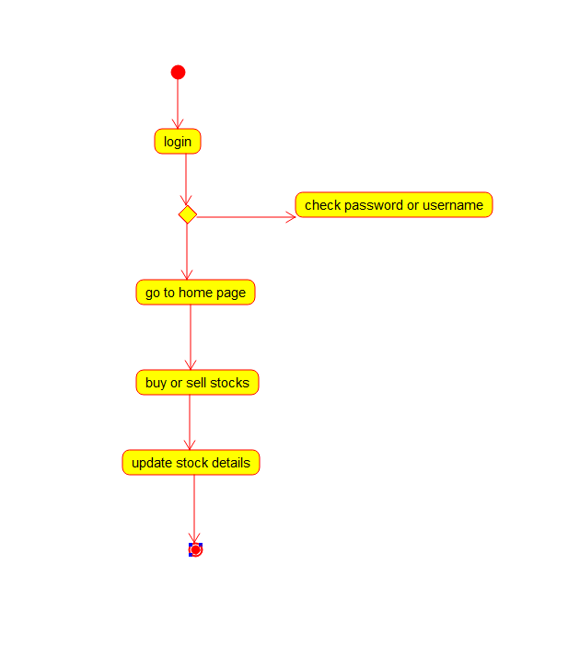

2.USECASE DIAGRAM: 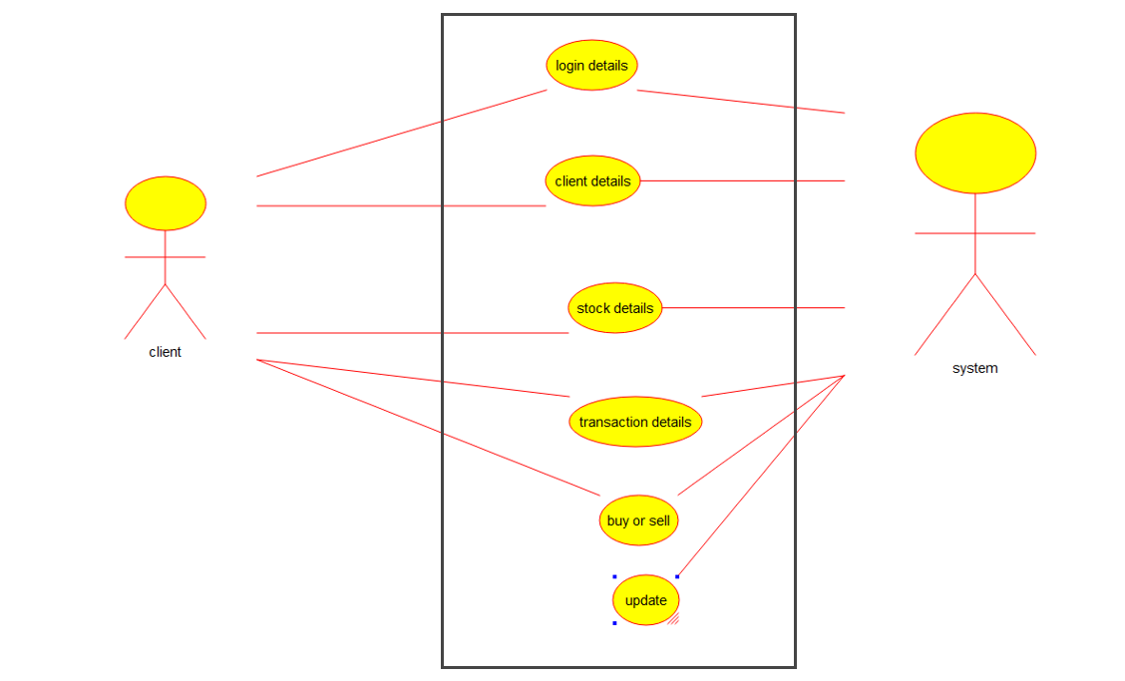

3.CLASS DIAGRAM:

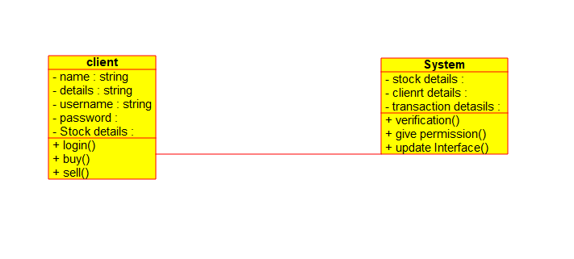

**25.AIM:-**

To develop a system using UML for Online Voting System.

UML DESIGNS:-

1.STATECHART DIAGRAM:

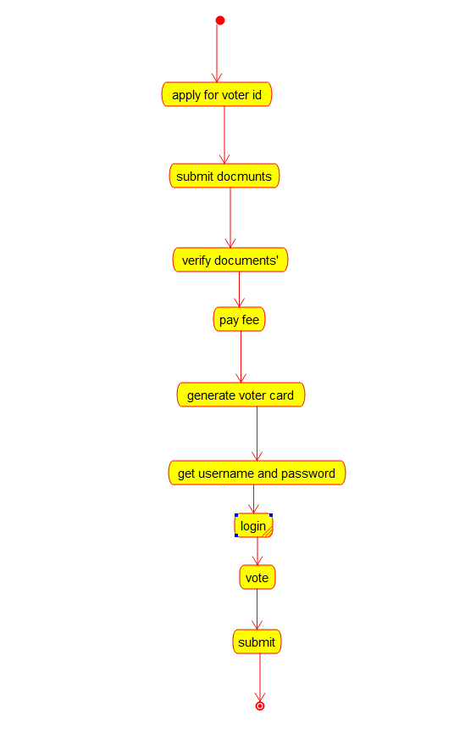

2.COLLABORATION DIAGRAM:

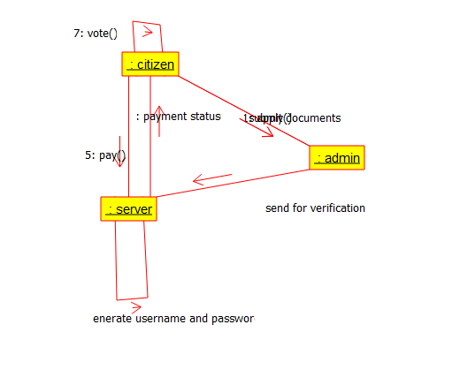

3.SEQUENCE DIAGRAM:

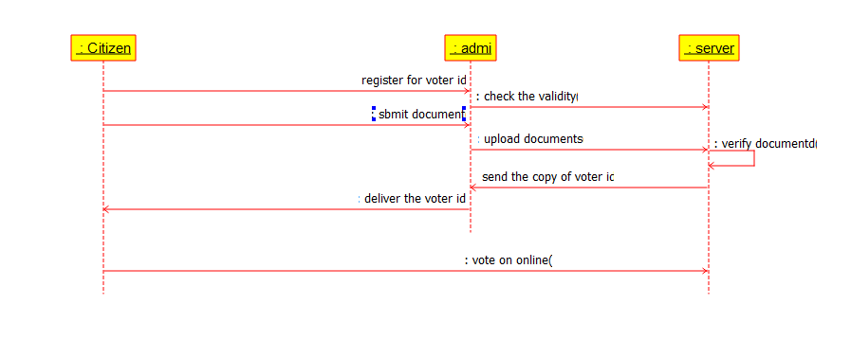

**26.AIM:-**

To develop a system using UML for Jewellery Shop Management System.

UML DESIGNS:-

1.SEQUENCE DIAGRAM:

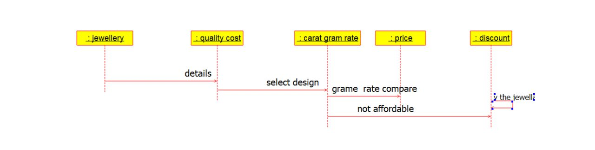

2.COMPONENT DIAGRAM:

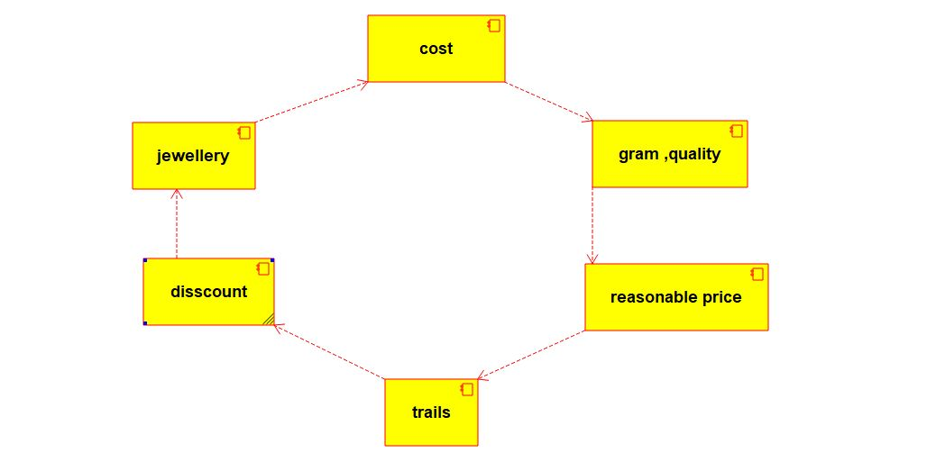

3.USECASE DIAGRAM:

